Desktop Multifunction Clamp PowerPod - 2x UK Sockets 2x USB 1x RJ45 (PDU-C-2W-2USB-1RJ45)

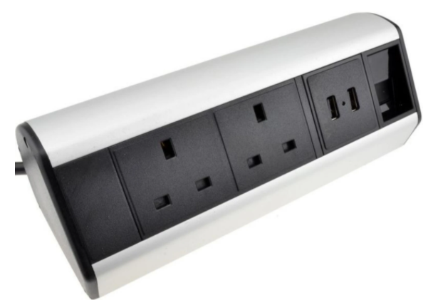

Description:
The LMS Power PDU-C-2W-2USB-1RJ45 is a versatile, desk-clamped power pod for your computers, mobile devices and other devices that need reliable power and charging points without the associated mess. The PowerPod also comes with a convenient RJ45 LAN port for computer network attachment.
Do away with messy extension blocks, trailing cables at home or in the office, the PowerPod simply clamps via its adjustable design to almost any table, desk or bench.
Stylish in design, fully adjustable clamp design makes for a stable power delivery platform. Robust aluminium chassis, a generous length power flex connected to a BSI rated 13 Amp UK plug.

Key Features:
Standard UK 3-Pin power outlets for all your desktop needs
Integral RJ45 LAN pass-through port
Integral dual USB charging points for your devices
Fully adjustable clamp design for table, desk or bench
Backed up by LMS Power's exclusive 3-year warranty

Applications:
Create instant power feeds to your data, telecom or server cabinets
Provide effective power for cabinet cooling fans, UPS systems
Ideal as stand-alone trailing sockets outside the cabinet

Product Code:
Part Number: PDU-C-2W-2USB-1RJ45
EAN: 8400800033598
Weight: 1.0 Kg approx

Technical Specifications:
Warranty LMS Data 3-Year Warranty
Clamp Fully adjustable clamping design
Output Sockets 3 UK 3-PIN Sockets
Network port 1 RJ45 UTP LAN pass through port
USB Ports 2 USB Charge Ports 5V, 2.1 Amp
Power Input Fitted UK 3PIN BSI Plug 13 Amp
Flex Length 1.8 metres (approx)

Supplied With:
PDU-C-2W-2USB-1RJ45 Clamp style PowerPod
Fitted 1.8 metre BSI UK 13 Amp flex and Plug
* Specifications and product design are subject to change. E&OE.

